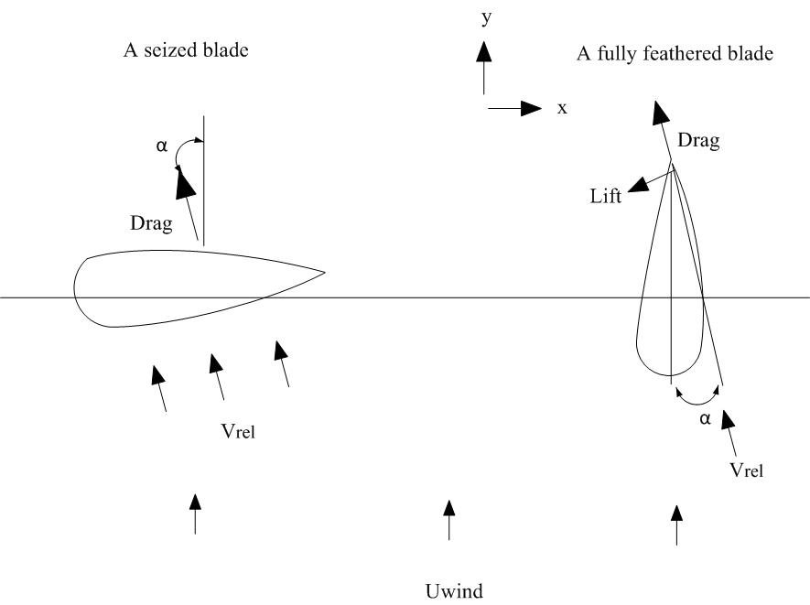

NACA 64_17 airfoil with aspect ratio of 17

**Seized blade**

For a parked wind turbine, the axial and rotational induction factors are negligible. All the blades are standstill yet moving with the spar-platform with velocity:



Where  are the surge, pitch and yaw motion velocity of the spar platform respectively. z and y are the coordinate of the blade node in global coordinate system. Vx,rel and Vy,rel are the relative motion of the blade besides the rigid body motion. For the environment with one year occurrence considered in this study, the maximum tip velocity Vy and Vx can be as large as 12.6 m/s and 8.8 m/s. Compared with the inflow wind velocity, these values are not small.

For a seized blade, the lift force is negligible and the drag force per unit length on a blade element can be approximated as



It can be inferred that the first term belongs to the excitation force while the second term is the damping force. The latter may not be negligible for the spar-type wind turbine under the environmental conditions considered. The first mode damping coefficient in the out-of-plane direction can thus be written as



It combines with the structural damping term to reduce the aerodynamic response. Compared with the normal parked cases, when one blade is seized and flat to the wind, the excitation term in the drag force may result in force in –y direction and create uneven moment about the –z axis, which could affect the surge and yaw motion of the platform. The first flapwise natural frequency of the blade is calculated as 0.64Hz, less than 1 Hz. Thus, wind excitation might induce significant resonant response of the seized blade.[1]

**Feathered blade**

For a fully feathered blade with pitch angle seized at 90 degree, the angle of attack at radius 45m is fluctuating around a mean value. This mean value, positive or negative, varies from case to case and stays usually less than 10 deg. Stall rarely occurs for a feathered blade and the lift force and the drag force can be written as





The forces can be resolved into components in the –x and –y direction:



Since CD and α are quite small. The damping coefficient in –x direction can be written as





The damping coefficient in –y direction can be written as



When the blades are feathered and parallel to the wind, there exist larger loads acting in –x direction with aerodynamic damping. The aerodynamic excitation and damping force in –y direction are relatively small due to the low angle of attack. In this situation, the blade structural damping is limiting the blade tip deflections. Unless blades are very flexible, aero-elastic instability such as flutter or galloping are usually not critical in practice[2] . These topics are not treated here.



Blade2seized, Wind direction=0, Wave direction=0, Uwind=38.7 m/s, I=0.12



Blade2seized, Wind direction=0, Wave direction=0, Uwind=38.7 m/s, I=0.12



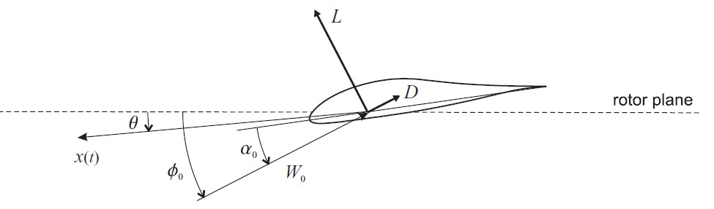











[1] Holmes JD. Wind loading of structures: Taylor & Francis Group; 2007.

[2] Burton T, Jenkins N, Sharpe D, Bossanyi E. Wind Energy Handbook. Wiley Online Library; 2011.